

**DEVI AHILYA VISHWAVIDYALAYA, INDORE**

**Vishaka Guidelines against Sexual Harassment in the Workplace**

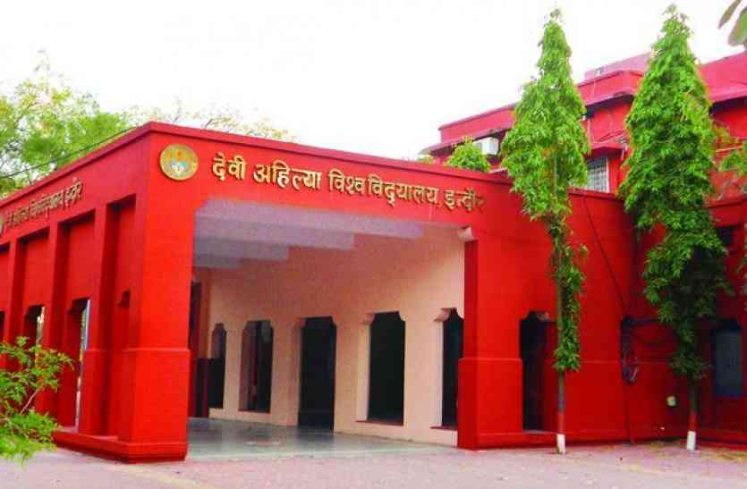

**Laws and Procedures: Sexual Harassment in the Workplace**

**Vishaka Guidelines against Sexual Harassment in the Workplace**

# Guidelines and norms laid down by the Hon’ble Supreme Court in Vishaka and Others Vs. State of Rajasthan and Others (JT 1997 (7) SC 384)

**HAVING REGARD** to the definition of „human rights‟ in Section 2 (d) of the Protection of Human Rights Act, 1993,

**TAKING NOTE** of the fact that the present civil and penal laws in India do not adequately provide for specific protection of women from sexual harassment in work places and that enactment of such legislation will take considerable time,

It is necessary and expedient for employers in work places as well as other responsible persons or institutions to observe certain guidelines to ensure the prevention of sexual harassment of women.

**1. Duty of the Employer or other responsible persons in work places and other institutions**

It shall be the duty of the employer or other responsible persons in work places or other institutions to prevent or deter the commission of acts of sexual harassment and to provide the procedures for the resolution, settlement or prosecution of acts, of sexual harassment by taking all steps required.

**2. Definition**

For this purpose, sexual harassment includes such unwelcome sexually determined behaviour (whether directly or by implication) as:

1. Physical contact and advances;
2. A demand or request for sexual favours;
3. Sexually coloured remarks;
4. Showing pornography;
5. Any other unwelcome physical, verbal or non-verbal conduct of sexual nature Where any of these acts is committed in circumstances where-under the victim of

such conduct has a reasonable apprehension that in relation to the victim‟s employment or

work whether she is drawing salary, or honorarium or voluntary, whether in government, public or private enterprise such conduct can be humiliating and may constitute a health and safety problem. It is discriminatory for instance when the woman has reasonable grounds to believe that her objection would disadvantage her in connection with her employment or work including recruiting or promotion or when it creates a hostile work environment. Adverse consequences might be visited if the victim does not consent to the conduct in question or raises any objection thereto.

**3. Preventive Steps**

All employers or persons in charge of work place whether in public or private sector should take appropriate steps to prevent sexual harassment. Without prejudice to the generality of this obligation they should take the following steps:

1. Express prohibition of sexual harassment as defined above at the work place should be notified, published and circulated in appropriate ways.
2. The Rules/Regulations of Government and Public Sector bodies relating to conduct and discipline should include rules/regulations prohibiting sexual harassment and provide for appropriate penalties in such rules against the offender.
3. As regards private employers, steps should be taken to include the aforesaid prohibitions in the standing orders under the Industrial Employment (Standing Orders) Act, 1946.
4. Appropriate work conditions should be provided in respect of work, leisure, health and hygiene to further ensure that there is no hostile environment towards women at work places and no employee woman should have reasonable grounds to believe that she is disadvantaged in connection with her employment.

**4. Criminal Proceedings**

Where such conduct amounts to a specific offence under the Indian Penal Code or under any other law, the employer shall initiate appropriate action in accordance with law by making a complaint with the appropriate authority.

In particular, it should ensure that victims, or witnesses are not victimized or discriminated against while dealing with complaints of sexual harassment. The victims of sexual harassment should have the option to seek transfer of the perpetrator or their own transfer.

**5. Disciplinary Action**

Where such conduct amounts to misconduct in employment as defined by the relevant service rules, appropriate disciplinary action should be initiated by the employer in accordance with those rules.

**6. Complaint Mechanism**

Whether or not such conduct constitutes an offence under law or a breach of the service rules, an appropriate complaint mechanism should be created in the employer‟s organisation for redress of the complaint made by the victim. Such complaint mechanism should ensure time bound treatment of complaints.

**7. Complaints Committee**

The complaint mechanism, referred to in (6) above, should be adequate to provide, where necessary, a Complaints Committee, a special counsellor or other support service, including the maintenance of confidentiality.

The Complaints Committee should be headed by a woman and not less than half of its member should be women. Further, to prevent the possibility of any undue pressure or influence from senior levels, such Complaints Committee should involve a third party, either NGO or other body who is familiar with the issue of sexual harassment.

The Complaints Committee must make an annual report to the Government department concerned of the complaints and action taken by them.

The employers and person in charge will also report on the compliance with the aforesaid guidelines including on the reports of the Complaints Committee to the Government department.

**8. Worker’s Initiative**

Employees should be allowed to raise issues of sexual harassment at a workers‟ meeting and in other appropriate forum and it should be affirmatively discussed in Employer- Employee Meetings.

**9. Awareness**

Awareness of the rights of female employees in this regard should be created in particular by prominently notifying the guidelines (and appropriate legislation when enacted on the subject) in a suitable manner.

**10. Third Party Harassment**

Where sexual harassment occurs as a result of an act or omission by any third party or outsider, the employer and person in charge will take all steps necessary and reasonable to assist the affected person in terms of support and preventive action.

1. The Central/State Governments are requested to consider adopting suitable measures including legislation to ensure that the guidelines laid down by this order are also observed by the employers in Private Sector.
2. These guidelines will not prejudice any rights available under the Protection of Human Rights Act, 1993.

***

Other legal provisions include filing a **criminal case** under sections of the Indian Penal Code (IPC), the Indecent Representation of Women (Prohibition) Act and/or filing a civil suit.

The sections of the **Indian Penal Code** that can be applicable to sexual harassment (which makes it a criminal case):

**1. Section 294**

„Whoever, to the annoyance of others, (a) does any obscene act in any public place, or

(b) sings, recites and utters any obscene songs, ballads or words, in or near any public space, shall be punished with imprisonment of either description for a term that may extend to three months, or with fine, or with both.‟ This provision is included in Chapter XVI entitled „Of Offences Affecting Public Health, Safety, Convenience and Morals‟ and is cognisable, bailable and triable by any magistrate.

**2. Section 354**

Whoever assaults or uses criminal force on any woman, intending to outrage her modesty or knowing it likely that he will thereby outrage her modesty, shall be punished with imprisonment for a term which may extend to two years, or with fine, or with both.

**3. Section 509**

(Word, gesture or act intended to insult the modesty of a woman) This is included in Chapter 22 entitled „Of Criminal Intimidation, Insult and Annoyance‟, and is cognisable, bailable and triable by any magistrate. It holds: „Whoever, intending to insult the modesty of

a woman, utters any word, makes any sound or gesture, or exhibits any object, intending that such word or sound shall be heard, or that such gesture is seen by such woman, or intrudes upon the privacy of such woman, shall be punished with simple imprisonment for a term which may extend to one year, or with fine, or with both.‟

Under the **Indecent Representation of Women (Prohibition) Act** (1987) if an individual harasses another with books, photographs, paintings, films, pamphlets, packages, etc. containing the “indecent representation of women”, they are liable for a minimum sentence of 2 years. Section 7 (Offenses by Companies) further holds companies where there has been “indecent representation of women” (such as the display of pornography) on the premises, guilty of offenses under this act, with a minimum sentence of 2 years.

**Civil case**

A civil suit can be filed for damages under tort laws. That is, the basis for filing the case would be mental anguish, physical harassment, loss of income and employment caused by the sexual harassment.