fnukad% 12.03.2019

This is to certify that total expenditure made on green initiatives and waste management by the University is as per details given below:
Details | 2017-18 | 2016-17 | 2015-16 | 2014-15 | 2013-14
Annual Budget Excluding Salary Component | 11503 | 11415 | 11203 | 11101 | 10106
Expenditure | 25.1 | 28.43 | 27.06 | 24.84 | 21.07

foÙk fu;a=d dqylfpo
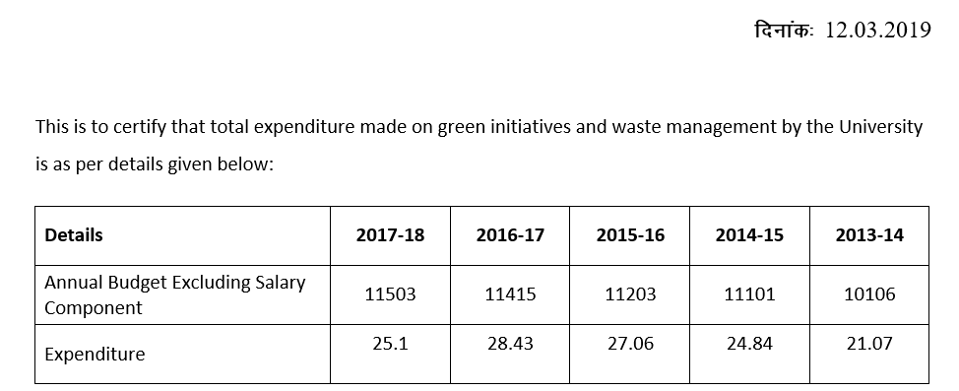
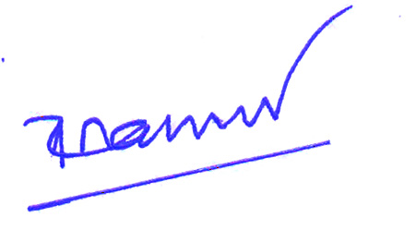

dqylfpo
