fnukad% 12.03.2019

This is to certify that the following facilities and resources are available in the institution for Divyangjan at Devi Ahilya Vishwavidyalaya, Indore.
S. No. | Facilities and Resources | Availability Status
 | Physical facilities | Yes
 | Provision for lift | Yes, (In administrative office, In UCC & and some departments
 | Ramp / Rails | Yes, in most of departments
 | Braille Software/facilities | Yes, (In Library 800 braille books, SCS, )
 | Rest Rooms | Yes
 | Scribes for examination | Yes
 | Special skill development for differently abled students | Yes, DDUKK organized a training program for specially abled children and then organized an exhibition for the sale of products made by them.
 | Any other similar facility (Specify) | Financial Aid given to students every year(List attached)

dqylfpo
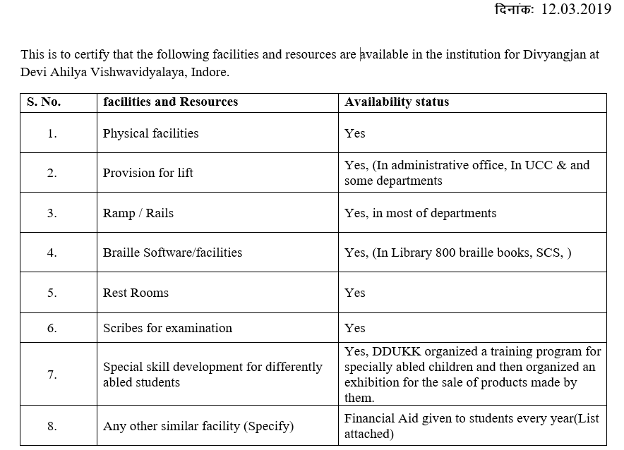



dqylfpo
