**BEST PRACTICES**

The University adopts several best practices for betterment of its students, faculty, governance etc. A few of them are listed below.

1. Devi Ahilya Women First Program
2. Transparency and Flexibility in Academics (Ordinance 14)
3. Regular Yoga and Meditation Sessions
4. Use of Technology in Governance
5. Transparency in Financial Administration
6. Credit Based Internship Program for enhancing employability

The top two best practices are being elaborated in the following section.

**A**

**Title of the Practice: Devi Ahilya ‘Women First’ program**

**Objectives of the Practice:**

Women are the most important members of our civilization serving multitude roles inside the family as well as in the society. These days the role of women has not been restricted to household rather many women are occupying high position in the society. They are excelling in almost every field viz., sports, humanities, science, socio - cultural fields etc. To encourage their overall development, government has not left any stone unturned. For promotion of talent in girls, occasional appreciation is an obligation. Whenever they get an opportunity they avail it to the fullest. There are approximately 50 % female students on campus. Devi Ahilya Vishwavidyalaya is sensitive towards Gender related issues and has taken proactive steps. The “*Devi Ahilya ‘Women First’ program”* was promulgated with the following objectives:

* To educate girls to be aware of their rights and legal remedies
* To make them mentally strong to resist injustice & achieve financial independence
* To spread awareness regarding health and related issues
* To align girls with the concept of Love yourself and feel “Proud to be a Women” and to create collective consciousness

**Context:**

Girls constitute approximately 50% of our available human resource, which sadly do not contribute to the nation in a commensurate proportion. Disparity leads to lack of confidence and creates dependence resulting in more crime against women. The solution to this age old problem lies in empowering girls through education and awareness.

**The Practice:**

The university formed a “Women’s Task Force” which started conducting programs for creating awareness and motivation among girl students. Subsequently, “Gender Equality Policy” was documented and applied. A bouquet of programs were designed and implemented over last few years. These include – Increasing role of women in administration, promoting activities to create gender equity, encouraging girls participation in cultural, sports and other activities and making them employable. Departmental women cells have been created, which is overseen by the University’s Women Cell.

The university has had fair representation of women right from the topmost level of administration in last five years, i.e. its executive council. Dr. Ragini Makhar, renowned Kathak dancer, Dr. Sunita Chandra, Dr.Geeta Marmat, Dr. Kusumlata Nigwal, Dr. Sumitra Waskel are a few to name. Around 50% Heads of Departments are women demonstrating our effective intent.

At student level, several initiatives were taken. Gender sensitivity issues were prominently discussed during the invocation programs with an aim to teach the boys to be sensitive and respectful to the opposite gender. Health camps for girls, lectures, seminars, poster competitions, skits and other activities were conducted to address female foeticide, Sexually transmitted diseases (STD’s), breast cancer awareness, Vaccines, etc. Women’s day and International women’s day celebrations were the part of our effort to make our girls proud of themselves. Our annual sports event SFOORTY mandates participation of girls in all sports event.

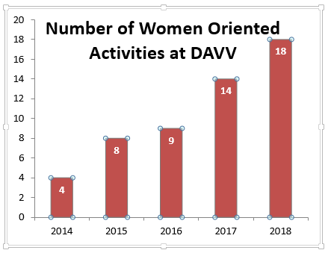

The university, in collaboration with Bhartiya Jain Sangathan, launched “Smart Girl program” which over the past two years has trained approximately 13000 girls in UTDs and affiliated colleges. The two days training covered modules related to Self –Awareness, Communication and Relationship, Self Esteem and Self Defense , Choices and Decisions, Friendship and Temptation, Dialogue with Parents. More than 500 university teachers were developed as master trainers to implement this program.

Counseling sessions for safety by police, in girls hostels, facilities like girls common room, Sanitary Pad vending machines are other regular features.

The university has also started appointing gender champions to inculcate the change in attitude towards girls.

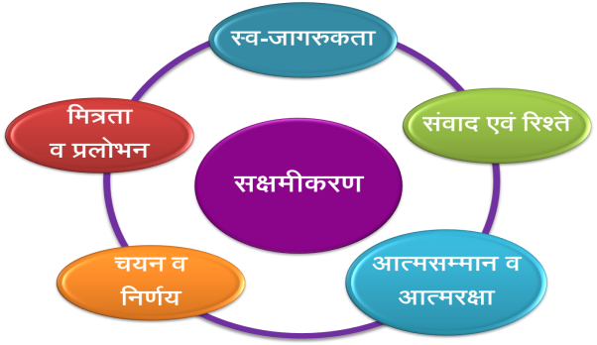

**Evidence of Success:**

a) Efforts in the direction of empowering our girls have surely yielded fruits. The girls have braught laurels to the university in academics, culture, sports etc. <ftp://naac.dauniv.ac.in/NAAC/Criteria%2007/7.2.1/7.2-Achievements%20of%20Girls%20in%20different%20events.pdf>

b) The female faculty members of the university have also achieved distinction in respective field. <ftp://naac.dauniv.ac.in/NAAC/Criteria%2007/7.2.1/7.2-Women%20Faculty%20Achievements.pdf>

c) The participation of students in the programs has been rising as evidenced by 300 workshops on Smart girl program (13000 Participants) <ftp://naac.dauniv.ac.in/NAAC/Criteria%2007/7.2.1/7.2-Smart%20Girls%20Workshops%20new.pdf>

d) Girls have been on higher side in winning awards in youth festivals. The list of Medalists in past 4 convocations of university shows that more than 80% medals were earned by girls. <ftp://naac.dauniv.ac.in/NAAC/Criteria%2007/7.2.1/7.2-All%20Medals%20list.pdf>

e) This increased interest is a testimony that gender related issues are now being discussed and an increased level of self-confidence is now gracefully evident in our girls. The fact of being equal propels our students to pursue challenging careers which is evident from placement data.

The efforts in women empowerment has transformed from the rudimentary gender awareness to gender sensitization to gender equity to empowerment and finally has culminated into celebrating women.

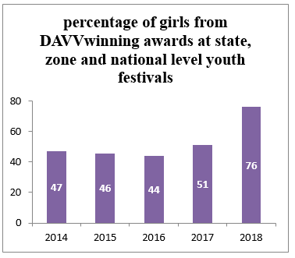

**Problems Encountered and Resources Required:**

The biggest challenge encountered has been to break the mental/psychological and the social barriers. To make the girls aware and to encourage those to talk on issues that have been traditionally considered forbidden/ fortressed was a major task. In the beginning the participation was forced rather than voluntary, which to an extent is obvious and understandable.

A university has a “Gender Equality Policy” which addresses the current and future issues. Most important resource required is of a dedicated budget. It is important to start a program on adoption of girls education from the weaker section of the society.

We feel that women empowerment programs should be a mandatory and regular event to be declared officially and prominently in the university calendar. The university needs to incorporate programs related to Gender Sensitivity under CBCS.

**B**

**Title of the Practice: Transparency and Flexibility in Academics –Ordinance 14 (Erstwhile Ordinance 31)**

**Objectives of the Practice**

The university is dedicated to ensure quality of its programs and transparency in evaluation process for all exams in all departments. The objective of this practice is to provide a fair mechanism of development & assessment of programs by experts and evaluation of students by teachers and to give opportunity to students to understand their performance in exams.

This ensures continuous up gradation of courses and timely results declaration and reduction in student grievances related to marks obtained. This practice of timely results helps the students further when they approach companies for recruitment or they plan for higher education.

**The Context**

The University departments needed freedom and flexibility for instituting, planning, monitoring, assessing and modifying educational programmes so that they are relevant and contemporary. At the same time students needed to be aware of their performance in exams. The overall evaluation system should called for transparency. After appropriate evaluation, there was a need for suitable and quick grievance redressal system. In case of DAVV, this was most essential as majority of it’s courses are professional and job oriented. The student’s are placed before exams and timely declaration of result is essential for their jobs. The Ordinance 31 which was originally incorporated in 1990 by coordination committee. Lastly it was revised in 2015 by incorporating CBCS and MOOCS.

**The Practice**

The university has adopted Re-Revised Ordinance 31 and it newly named as Ordinance 14, approved by University Coordination committee on 26th June 2015 (<http://www.dauniv.ac.in/rules/ReRevisedOrdinance31.pdf>). This Ordinance gives flexibility to all academic programs run by all UTDs and they can institute, plan, monitor, assess and modify their educational programs.

The university runs several professional and job oriented programs where timely completion of exams and declaration of results is important and at the same time, transparency in evaluation is essential. Therefore, the point number 14 and 15 of ordinance 31, as quoted below, ensure flexibility and transparency -

*“ Pont 14. Evaluation will be internal with feedback system, i.e. marked answer books will be shown to the student for his/her perusal and will be collected back by the teacher for record for six months after declaration of the result.*

*Link To be inserted*

*Point 15. The decision of the teacher regarding the evaluation and the grade shall be final. However, a student can submit in writing for review of his Marks/Grade to the Head/Director who will place the case before the Board of comprehensive viva-voce. The decision of the board will be final. Result of the review will be declared by the concerned Head/Director. Review is effective only if the grade improves. Review will be allowed if-*

*\* The prescribed fee is paid*

*\* The candidate applies within 7 days of the declaration of the grade in that course.”*

Also, the Point number 18.3, quoted below, ensures that the curriculum, pedagogy and overall teaching is assessed regularly and changes are made as and when required.

*Point 18.3 The external expert of the comprehensive viva-voce board shall also conduct an academic audit and make an assessment of overall knowledge gain by the students in the semester, standard of question papers, syllabus covered, marking in valuation of answer books, etc. and shall submit its report to vice chancellor through Head/Director*

Due to the above mentioned provisions of Ordinance 31, the teachers ensure that they show marked answer copies to students and give them feedback on their performance. This gives the teacher authority to evaluate the performance of his student. But at the same time, if a student is not satisfied with the marking, he has the right to apply for revaluation. Generally this process is completed before the comprehensive viva voce of the students. So that, grievances if any can be handled in appropriate time. The comprehensive viva voce board has external examiner appointed by the vice chancellor, who apart from examining the students, also conducts the academic audit of the program.

**Evidence of Success**.

The Ordinance 31 has helped the university in three ways –

a) Academic Autonomy enables to offer new professional and vocational programs and updating the syllabus of existing programs.

<ftp://naac.dauniv.ac.in/NAAC/Criteria%2001/1.1.3/1.1.3-Additonal%20Information.pdf>

b) Declaring results in time <ftp://naac.dauniv.ac.in/NAAC/Criteria%2007/7.2.1/Certificate%20of%20result%20declaration.pdf>

c) Maintaining transparency in evaluation and reduction in number of grievances related to results.

<ftp://naac.dauniv.ac.in/NAAC/Criteria%2007/7.2.1/Sample%20answer%20copies.pdf>

The university offers several programs out of which 60% are professional and vocational in nature. This has helped increase the job placement for it’s students as now they are more industry ready having read suitable courses. Around 80 to 90% of students of these programs are getting placed.

The departments complete the evaluation of answer books well in time, mostly before the comprehensive viva, so that the result can be declared as soon as possible. The average time of declaration of results has declined substantially-from few months to just within 30 days. The companies hiring these students are happy as the students are able to provide result of course completion in time. The number of grievances related to results has gone down considerably (almost nil) in the past years. Thus, overall academic environment has been boosted due to the provisions of ordinance 31. Moreover, it has also helped in bringing a uniformity and enhancing quality of all teaching departments.

**Problems Encountered and Resources Required**

The university has 31 teaching departments, & centers and caters to more than 10,000 students at a time. Some of the larger departments like Institute of Engineering Technology, Institute of Management Studies, International Institute of Professional Studies etc are densely populated with a strength as high as 2500 students. Timely evaluation of all answer copies and declaration of result requires tremendous efforts by the faculty members.

It also requires lot of effort in terms of coordination among different teams for final declaration of result.

The flexibility given by this ordinance to revise the syllabus as per industry needs, make the process dynamic and it calls for consistent feedback from various stakeholders, revisions and other procedural challenges. This also requires the faculty members to be updated with newer knowledge.

Link of the ordinance: <http://www.dauniv.ac.in/rules/ReRevisedOrdinance31.pdf>