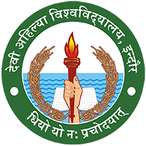

**DEVI AHILYA VISHWAVIDYALAYA, INDORE**

**Achievements of Girls in different events**

